COPYMASTER |  |  |  | COPY TONE: CASUAL |  |  |  |  |  |  |  |  |  | VERSION: 1.06
Project Name: iX1_arx |  |  |  | Product Name: HELIOS NEO 18 AI |  |  |  |  |  |  |  |  |  | Product Type: high-performance  intel Gaming Laptop
Writer: Clark Gurden |  |  |  | Central MKT: Sylvia Pan  Product MKT: Clark Gurden |  |  |  |  |  |  |  |  |  | FCS:
1.04-1.05  2-11-25 |  |  |  | Changed DLSS on A+ section
1.05->1.06 |  |  |  | Added NV to sections where only GeForce was mentioned  -meta, key message,  Reduced copy length in sections that would require retranslation
//AGW Meta Content
Page Title (60) |  |  |  |  |  | PREDATOR HELIOS NEO 18 AI | Intel® Gaming Laptop
Meta Description (160) |  |  |  |  |  | Powered by up to an Intel® Core™ Ultra 9 processor, an NVIDIA® GeForce RTX™ 5070 Ti Laptop GPU, an 18” Mini LED display with WQXGA resolution at 250Hz, advanced cooling, Wi-Fi 6E, and DTS® X: Ultra for peak performance and seamless connectivity.
//Line/Class Content
Shortened KM (120)  Series Card |  |  |  |  |  | Revolutionary AI performance, breathtaking visuals, and advanced cooling—built to elevate your gaming experience.
//AGW Page Content / Banner
Banner Content - Product Name/Header (40) |  |  |  |  |  | PREDATOR HELIOS NEO 18 AI
Banner Content – Description (120) |  |  |  |  |  | POWER REIMAGINED, PRECISION UNLEASHED
Key Message/Page Intro
Key Message/Intro (220) |  |  |  |  |  | With up to an Intel® Core™ Ultra 9 processor, an NVIDIA® GeForce RTX™ 5070 Ti Laptop GPU and Mini LED display delivering unparalleled color accuracy and refresh rates, this powerhouse is ready for gamers and professionals alike.
Logos / Badges / Awards
Windows 11home |  |  |  |  |  |  |  |  | 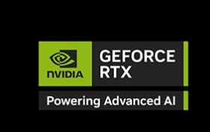 |  |  |  |  |  | Dts: X ultra |  |  |  |  |  |  | 
//Media Gallery Content
Logo Permission (yes/no)
Media Reviewer Name
Included Quote Portion
Media Review Link
Partner / Performance KSP
KSP Headline (40) |  |  |  |  |  | DESKTOP-LEVEL PERFORMANCE, ANYWHERE.
KSP Body (250) |  |  |  |  |  | Get legendary gaming performance with the Intel® Core™ Ultra 9 processor, delivering ultra-smooth gameplay and future-ready AI. Offload tasks like background removal and audio optimization to the NPU for seamless streaming, while Intel® Application Optimization™ enhances performance on classic titles.
Overline (20) |  |  |  |  |  |  |  |  |  |  | Up to Intel® |  |  |  |  | Up to |  |  |  |  |  |  | Up to
Spec (30) |  |  |  |  |  | WINDOWS 11 HOME |  |  |  |  | CORE™ ULTRA 9 275HX |  |  |  |  | 24 CORES |  |  |  |  |  |  | 5.4GHZ
Underline (20) |  |  |  |  |  | Operating System |  |  |  |  | processor |  |  |  |  | 8P + 16E |  |  |  |  |  |  | P-core Max Turbo Freq.
Partner KSP / Graphics (NVIDIA KSP)
KSP Headline (40) |  |  |  |  |  | Game Changer
 |  |  |  |  |  | GeForce RTX 50 Series Laptops
KSP Body (250) |  |  |  |  |  | Powered by NVIDIA Blackwell and AI
Overline (20) |  |  |  |  |  | Up to NVIDIA® |  |  |  |  |  | Up to |  |  |  |  | NVIDIA®
Spec (30) |  |  |  |  |  | GEFORCE RTX™ 5070 Ti |  |  |  |  |  | 140W MGP |  |  |  |  | ADVANCED OPTIMUS |  |  |  |  |  |  | 5TH GEN TENSOR CORES
Underline (20) |  |  |  |  |  | Laptop GPU |  |  |  |  |  | with Dynamic Boost |  |  |  |  | Equipped |  |  |  |  |  |  | Max AI Performance
Subline |  |  |  |  |  | (992 AI TOPS) |  |  |  |  |  |  |  |  |  |  |  |  |  |  |  |  |  | with FP4 & DLSS 4
Grouped Partner Features
Image reference |  |  |  |  |  |  |  |  |  |  |  |  |  |  |  |  | 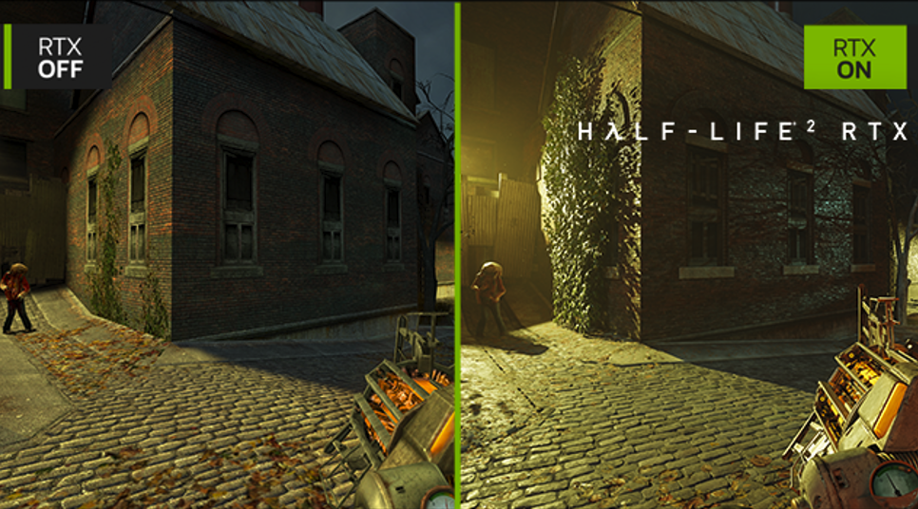
Tech Headline |  |  |  |  |  | DLSS 4 |  |  |  |  |  |  |  |  |  |  | FULL RAY TRACING WITH NEURAL RENDERING
Features Headline |  |  |  |  |  | SUPREME SPEED. SUPERIOR VISUALS. POWERED BY AI. |  |  |  |  |  |  |  |  |  |  | GAME-CHANGING REALISM
Features Body |  |  |  |  |  | DLSS is a revolutionary suite of neural rendering technologies that uses AI to boost FPS, reduce latency, and improve image quality. ‌The latest breakthrough, DLSS 4, brings new Multi Frame Generation and enhanced Ray Reconstruction and Super Resolution, powered by GeForce RTX™ 50 Series GPUs and fifth-generation Tensor Cores. DLSS on GeForce RTX is the best way to play, backed by an NVIDIA AI supercomputer in the cloud constantly improving your PC’s gaming capabilities. |  |  |  |  |  |  |  |  |  |  | The NVIDIA Blackwell architecture unlocks the game-changing realism of full ray tracing. Experience cinematic quality visuals at unprecedented speed powered by GeForce RTX 50 Series with fourth-gen RT Cores and breakthrough neural rendering technologies accelerated with fifth-gen Tensor Cores.
Image reference |  |  |  |  |  | 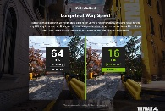 |  |  |  |  |  |  | 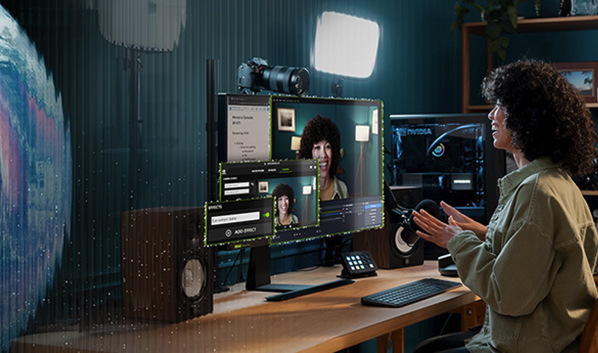 |  |  |  |  |  |  |  | 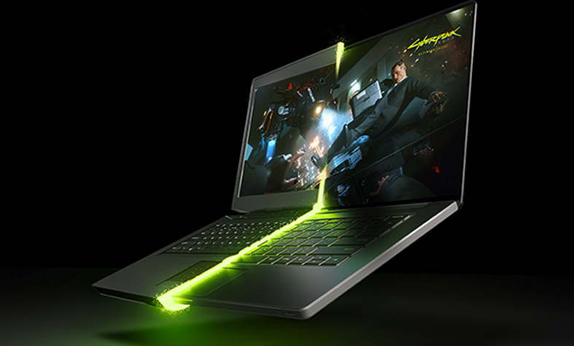
Tech Headline |  |  |  |  |  | REFLEX 2 |  |  |  |  |  |  | RTX AI PC |  |  |  |  |  |  |  | NVIDIA BLACKWELL MAX-Q
Features Headline |  |  |  |  |  | COMPETE AT WARP SPEED |  |  |  |  |  |  | NVIDIA POWERS THE  WORLD’S AI. AND YOURS. |  |  |  |  |  |  |  | OPTIMIZED POWER AND PERFORMANCE
Features Body |  |  |  |  |  | Reflex technologies optimize the graphics pipeline for ultimate responsiveness, providing faster target acquisition, quicker reaction times, and improved aim precision in competitive games. Reflex 2 introduces Frame Warp, which further reduces latency based on the game’s latest mouse input. |  |  |  |  |  |  | Upgrade to advanced AI with NVIDIA GeForce RTX™ GPUs and accelerate your gaming, creating, productivity, and development. Thanks to built-in AI processors, you get world-leading AI technology powering your Windows PC. |  |  |  |  |  |  |  | Max-Q is designed from the ground up for maximum efficiency, delivering a massive leap in performance and battery life.
KSP
KSP Headline (40) |  |  |  |  |  | VIBRANT MINI LED DISPLAY
KSP Body (250) |  |  |  |  |  | Immerse yourself in stunning visuals with up to an 18” Mini LED WQXGA display. Featuring up to 250Hz refresh rate and DCI-P3 100% color accuracy, every scene comes to life.
Overline (20) |  |  |  |  |  | Up to 16:10 |  |  |  |  | Up to |  |  |  |  | Brilliant |  |  |  |  |  |  | Equipped with
Spec (30) |  |  |  |  |  | MINI LED WQXGA |  |  |  |  | 250HZ / 3MS |  |  |  |  | DCI-P3 100% |  |  |  |  |  |  | NVIDIA® G-SYNC®
Underline (20) |  |  |  |  |  | 2560 X 1600 Display |  |  |  |  | Refresh / Response |  |  |  |  | Wide Color Gamut |  |  |  |  |  |  | Technology
KSP
KSP Headline (40) |  |  |  |  |  | ADVANCED COOLING SYSTEM
KSP Body (250) |  |  |  |  |  | Stay ahead of the heat with 5th Gen AeroBlade™ 3D fans, liquid metal grease, and precision-engineered airflow. Designed to keep your system running smoothly, no matter the challenge.
KSP
KSP Headline (40) |  |  |  |  |  | CONTROL WITH PREDATORSENSE™ AND EXPERIENCE ZONE
KSP Body (250) |  |  |  |  |  | PredatorSense™ gives you real-time control over system performance—adjust performance modes, manage fan speeds, and customize RGB lighting with precision. In the Experience Zone, tap into AI-powered features like PurifiedView for automatic framing and PurifiedVoice™ 2.0 for enhanced voice clarity.
Features Headline |  |  |  |  |  | ACER PROCAM™ |  |  |  |  |  |  | ACER PURIFIEDVIEW™ 2.0 |  |  |  |  |  |  |  | ACER PURIFIEDVOICE™ 2.0
Features Body |  |  |  |  |  | Acer ProCam automatically recognizes gameplay highlights and records those moments. |  |  |  |  |  |  | Step into a world of AI-enhanced clarity with advanced Portrait Refinement, Super Sharp visuals, and automatic framing. Enjoy natural background blur, gaze correction, and Acer TNR for vibrant, sharper images, even in low light. Perfect for seamless virtual meetings, live streaming, and video calls. |  |  |  |  |  |  |  | Utilizing AI algorithms and a 3rd mic to identify and suppress unwanted background noise, Acer PurifiedVoice™ 2.0 delivers distraction-free audio for more engaging communication experiences.
KSP
KSP Headline (40) |  |  |  |  |  | DYNAMIC 4-ZONE RGB LIGHTING
KSP Body (250) |  |  |  |  |  | Personalize your rig with 4-zone RGB keyboard lighting and customizable cover illumination. Designed for those who want to make their setup as unique as their gameplay.
KSP
KSP Headline (40) |  |  |  |  |  | OPTIMIZE WITH INTEL® APPLICATION OPTIMIZATION
KSP Body (250) |  |  |  |  |  | Experience constant evolution with Intel® Application Optimization™. AI-driven updates fine-tune your system’s performance, giving you the upper hand in select titles. Intel® APO ensures smoother gameplay, less latency, and automatic enhancements for the games that matter most.
KSP
KSP Headline (40) |  |  |  |  |  | DISCOVER YOUR NEXT FAVORITE GAME
KSP Body (250) |  |  |  |  |  | Play hundreds of PC games with your new Acer Predator Windows 11 PC and three months of PC Game Pass, including EA Play. With new games added all the time, there’s always something new to play.
Disclaimers
 |  | This product is not designed for cryptocurrency mining uses. Damages to your product arising from cryptocurrency mining or related activities are excluded from your product’s warranty.
 |  | The terms HDMI and HDMI High-Definition Multimedia Interface and the HDMI Logo are trademarks or registered trademarks of HDMI Licensing Administrator, Inc. in the United States and other countries.
Intel® technologies’ features and benefits depend on system configuration and may require enabled hardware, software, or service activation. Performance varies depending on system configuration. No product or component can be absolutely secure.

© Intel Corporation. Intel, the Intel logo, and other Intel marks are trademarks of Intel Corporation or its subsidiaries. Other names and brands may be claimed as the property of others.
 |  | ©2025 NVIDIA Corporation. NVIDIA, the NVIDIA logo, GeForce, and GeForce RTX are registered trademarks and/or trademarks of NVIDIA Corporation in the United States and other countries. All other trademarks and copyrights are the property of their respective owners.
 |  | Intel® Application Optimization is a policy within Intel® Dynamic Tuning Technology that optimizes performance on select games, with required configurations on select Intel® Core 14th Gen processors. For additional information on Intel® Application
 |  | The frequency of cores and core types varies by workload, power consumption and other factors. Visit https://www.intel.com/content/www/us/en/architecture-and-technology/turbo-boost/turbo-boost-technology.html for more information.
 |  | Max Turbo Frequency is the maximum single-core frequency at which the processor is capable of operating using Intel® Turbo Boost Technology and, if present, Intel® Turbo Boost Max Technology 3.0 and Intel® Thermal Velocity Boost. Frequency is typically measured in gigahertz (GHz), or billion cycles per second.
 |  | Intel® Turbo Boost Max Technology 3.0 identifies the best performing core(s) on a processor and provides increased performance on those cores through increasing frequency as needed by taking advantage of power and thermal headroom. Intel® Turbo Boost Max Technology 3.0 frequency is the clock frequency of the CPU when running in this mode.
 |  | Maximum P-core turbo frequency derived from Intel® Turbo Boost Technology.
 |  | AI features may require software purchase, subscription or enablement by a software or platform provider, or may have specific configuration or compatibility requirements. Details at www.intel.com/aipc.
 |  | PC Game Pass: Subscription continues automatically at regular monthly price unless cancelled. Subject to xbox.com/subscriptionterms. Terms and exclusions apply. Game catalog varies over time, by region, and by device. All rights reserved. xbox.com/pcgamepass, ea.com/ea-play/terms. (above disclaimer is from the FY25 Xbox marketing guideline for your reference)
 |  | Copilot may require Windows Update or app download from the Microsoft Store.
 |  | Copilot availability and rollout timing varies by market and is subject to updates from Microsoft.
 |  | Specifications may vary depending on model and/or region. All models subject to availability.
 |  | Depending on the region, this laptop may be bundled with a mouse. In such case, the mouse may not support NVIDIA Reflex 2 functionality. Acer does not claim or guarantee compatibility of the bundled mouse with this feature.
// A+ ETAIL / KV CONTENT
Product Name |  |  |  |  |  | PREDATOR HELIOS NEO 18 AI
KV Bullets |  |  |  |  |  | - Up to Intel® Core™ Ultra 9 processor  - Up to GeForce RTX ™ 5070 Ti Laptop GPU (992 AI TOPS)  - Up to 16” Mini LED WQXGA, Up to 250Hz Refresh, 3ms Response, 100% DCI-P3  - 5th Gen AeroBlade™ 3D Fan Technology  - PredatorSense™ & Experience Zone AI Software Suite  - Thunderbolt™ 4, HDMI 2.1, Killer™ Wi-Fi 6E
KV Disclaimers
 |  |  |  |  |  | Specifications may vary depending on model and/or region. All models subject to availability.
Key Message  (220 Max) |  |  |  |  |  | With up to an Intel® Core™ Ultra 9 processor, an NVIDIA® GeForce RTX™ 5070 Ti Laptop GPU and Mini LED display delivering unparalleled color accuracy and refresh rates, this powerhouse is ready for gamers and professionals alike. Advanced cooling ensures consistent performance, while Wi-Fi 6E and Thunderbolt™ 4 provide the high-speed connectivity you need.
Short KM (100) |  |  |  |  |  | Revolutionary AI performance, breathtaking visuals, and advanced cooling—built to elevate your gaming experience.
 |  |  |  |  |  |  |  |  |  |  |  |  |  |  |  |  |  |  | 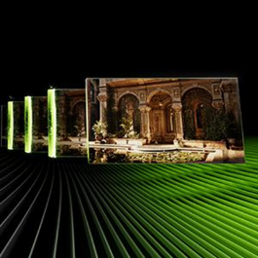
DESKTOP-LEVEL PERFORMANCE, ANYWHERE. |  |  |  |  |  |  |  | The Ultimate in Ray Tracing and AI |  |  |  |  |  |  |  |  |  |  | Supreme Speed. Superior Visuals. Powered by AI.
Get legendary gaming performance with the Intel® Core™ Ultra 9 processor, delivering ultra-smooth gameplay and future-ready AI. Offload tasks like background removal and audio optimization for seamless streaming, while Intel® Application Optimization™ enhances performance on classic titles. |  |  |  |  |  |  |  | NVIDIA RTX is the most advanced platform for full ray tracing and neural rendering technologies that are revolutionizing the ways we play and create. Over 700 games and applications use RTX to deliver realistic graphics and incredibly fast performance with cutting-edge AI features like DLSS Multi Frame Generation. |  |  |  |  |  |  |  |  |  |  | NVIDIA DLSS is a revolutionary suite of neural rendering technologies that uses AI to boost FPS, reduce latency, and improve image quality. ‌DLSS 4 brings new Multi Frame Generation and enhanced Ray Reconstruction and Super Resolution, powered by GeForce RTX™ 50 Series GPUs and fifth-gen Tensor Cores.
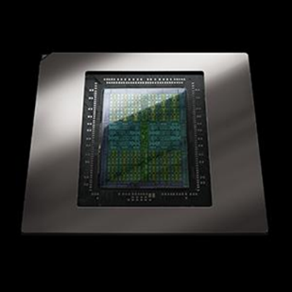
Game-Changing Realism |  |  |  |  |  |  |  | VIBRANT MINI LED DISPLAY |  |  |  |  |  |  |  |  |  |  | ADVANCED COOLING SYSTEM
Powered by the NVIDIA Blackwell architecture, GeForce RTX 50 Series GPUs unlock the game-changing realism of full ray tracing. Experience cinematic quality visuals at unprecedented speed with fourth-gen RT Cores and breakthrough neural rendering technologies accelerated with fifth-gen Tensor Cores. |  |  |  |  |  |  |  | Immerse yourself in stunning visuals with up to an 18” Mini LED WQXGA display. Featuring up to 250Hz refresh rate and DCI-P3 100% color accuracy, every scene comes to life. |  |  |  |  |  |  |  |  |  |  | Stay ahead of the heat with 5th Gen AeroBlade™ 3D fans, liquid metal grease, and precision-engineered airflow. Designed to keep your system running smoothly, no matter the challenge.
ENHANCED CONNECTIVITY |  |  |  |  |  |  |  | DYNAMIC 4-ZONE RGB LIGHTING |  |  |  |  |  |  |  |  |  |  | OPTIMIZE WITH INTEL® APPLICATION OPTIMIZATION
Wi-Fi 6E, Thunderbolt™ 4, and HDMI 2.1 combine to deliver high-speed connectivity for seamless gaming, streaming, and data transfer. |  |  |  |  |  |  |  | Personalize your rig with 4-zone RGB keyboard lighting and customizable cover illumination. Designed for those who want to make their setup as unique as their gameplay. |  |  |  |  |  |  |  |  |  |  | Experience constant evolution with Intel® Application Optimization™. AI-driven updates fine-tune your system’s performance, giving you the upper hand in select titles. Intel® APO ensures smoother gameplay, less latency, and automatic enhancements for the games that matter most.
DISCOVER YOUR NEXT FAVORITE GAME
Play hundreds of PC games with your new Acer Predator Windows 11 PC and three months of PC Game Pass, including EA Play. With new games added all the time, there’s always something new to play.
DISCLAIMERS
 | This product is not designed for cryptocurrency mining uses. Damages to your product arising from cryptocurrency mining or related activities are excluded from your product’s warranty.
 | The terms HDMI and HDMI High-Definition Multimedia Interface and the HDMI Logo are trademarks or registered trademarks of HDMI Licensing Administrator, Inc. in the United States and other countries.
Intel® technologies’ features and benefits depend on system configuration and may require enabled hardware, software, or service activation. Performance varies depending on system configuration. No product or component can be absolutely secure.

© Intel Corporation. Intel, the Intel logo, and other Intel marks are trademarks of Intel Corporation or its subsidiaries. Other names and brands may be claimed as the property of others.
 | ©2025 NVIDIA Corporation. NVIDIA, the NVIDIA logo, GeForce, and GeForce RTX are registered trademarks and/or trademarks of NVIDIA Corporation in the United States and other countries. All other trademarks and copyrights are the property of their respective owners.
 | Intel® Application Optimization is a policy within Intel® Dynamic Tuning Technology that optimizes performance on select games, with required configurations on select Intel® Core 14th Gen processors. For additional information on Intel® Application
 | AI features may require software purchase, subscription or enablement by a software or platform provider, or may have specific configuration or compatibility requirements. Details at www.intel.com/aipc.
 | PC Game Pass: Subscription continues automatically at regular monthly price unless cancelled. Subject to xbox.com/subscriptionterms. Terms and exclusions apply. Game catalog varies over time, by region, and by device. All rights reserved. xbox.com/pcgamepass, ea.com/ea-play/terms. (above disclaimer is from the FY25 Xbox marketing guideline for your reference).
 | Specifications may vary depending on model and/or region. All models subject to availability.
 | Depending on the region, this laptop may be bundled with a mouse. In such case, the mouse may not support NVIDIA Reflex 2 functionality. Acer does not claim or guarantee compatibility of the bundled mouse with this feature.

